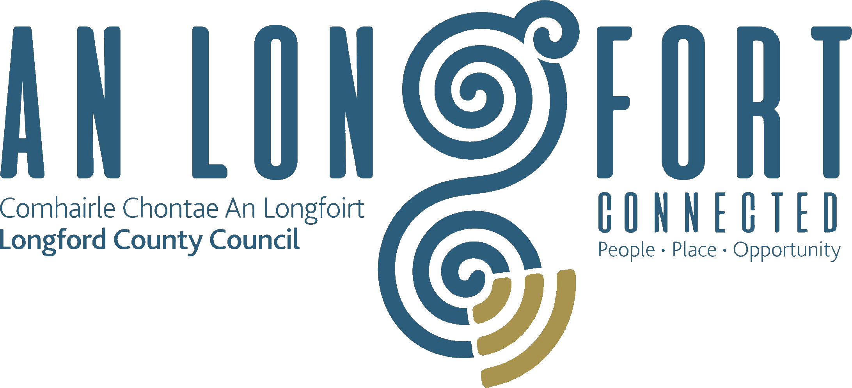

BALLYMAHON MUNICIPAL DISTRICT

Minutes of Meeting of Ballymahon Municipal District held in Ballymahon Community Library on Thursday, 26th July 2018 at 4.30 p.m.

CATHAOIRLEACH: Councillor Paul Ross

MEMBERS PRESENT: Councillors – Mick Cahill, Mark Casey,
Gerard Farrell, Colm Murray and Pat O’Toole.

IN ATTENDANCE: Ms. Nora O’Farrell, Acting Director of Services.
Ms. Linda Higgins, Administrative Officer
Mr. Paul Newell, Senior Executive Engineer.

MEETINGS
ADMINISTRATOR: Ms. Anne Lee.

ADOPTION OF MINUTES.

On the proposal of Councillor M. Cahill seconded by Councillor C. Murray, the Minutes of Committee Meeting of Ballymahon Municipal District held on the 3rd May 2018, as circulated, were confirmed and adopted.

On the proposal of Councillor M. Cahill seconded by Councillor C. Murray, the Minutes of Meeting of Ballymahon Municipal District held on the 3rd May 2018, as circulated, were confirmed and adopted.

On the proposal of Councillor M. Cahill seconded by Councillor C. Murray, the Minutes of 2018 Annual Meeting of Ballymahon Municipal District held on the 21st June 2018, as circulated, were confirmed and adopted.

MATTERS ARISING FROM MINUTES.

Retrofitting of doors and windows in Houses in St. Matthew's Park, Ballymahon.

L. Higgins stated that following from MD Meeting held in May and queries regarding retrofitting of doors and windows in houses in St. Matthew's Park, Ballymahon, the Housing Section gave the following report –

“ Longford County Council are in ongoing discussions with the Department of Housing, Planning and Local Government regarding funding for the survey and the improvement works that will be required. The Department recently announced funding for phase two energy retrofit works. The Council has made a submission and subject to approval will commence a programme of replacement of windows and doors on a priority basis which will improve the condition of the housing stock.”

MANAGEMENT REPORT.

The Management Report, as circulated, was noted.

APPLICATIONS FOR FUNDING UNDER THE 2018 COMMUNITY GRANT
SUPPORT SCHEME.

Additional applications which were received under the Community Support Scheme and recommendations were noted and agreed.

REPORT ON BURIAL GROUNDS - Circulated.

The following was agreed by the members -

Repair of damaged wall at Shrule Cemetery -
Total Cost - €2,200 - €1,100 to be paid this year, and €1,100 ring-fenced for payment in 2019.

Contribution of €7,500 by Longford County Council to LCRL towards Cemetery Maintenance in 2018 - €2,171 for 2018 - based on the number of cemeteries maintained by LCRL in Ballymahon Municipal District.

Cloncallow Cemetery.
€350 towards the cost of erecting a fence along the approach road to Cloncallow Cemetery.

Kilcommock Cemetery.
€750 towards the cost of repairs to the boundary walls at Kilcommock Cemetery.

Recommendations from the Municipal District to the Infrastructure and Environment Strategic Policy Committee -

- If no existing policy in place a new policy regarding Cemetery Extensions/Purchases should be prepared, with MD input. The members also requested that any existing policy should be circulated to the MD Members.
- There should be a defined closing date for the receipt of applications for funding.
- A standard application form for Cemetery Funding should be available in the three Municipal Districts.
- The final decision regarding Cemetery Funding should be made by the Municipal District members, as the funding is part of the approved G.M.A.

UPGRADE OF AMENITIES.

P. Newell informed the members that a sum of €30,000 was provided in the Capital Programme each year since 2017 for capital expenditure on amenities. It was agreed that the budget should be allocated equally between each Municipal District and spent on the upgrade of existing Council amenities.

€20,000 is the available funding for the Ballymahon MD area (2017 and 2018 allocation).

The following was agreed by the members -

(a) Barley Harbour- €15,000 – to include picnic furniture, repairs to pier, disability car park area, signage upgrade etc.
It was agreed that an overall plan should be prepared for Barley Harbour and the Regeneration Sub-Committee be requested to investigate what funding would be available for works at Barley Harbour.
(b) Pallas – (birthplace of Oliver Goldsmith) €5,000 – to include disability access , signage upgrade etc.

NOTICES OF MOTIONS.

Speed Ramps at Smithfield Crescent Housing Estate, Legan.

The following Notice of Motion was proposed by Councillor P. Ross and seconded by
Councillor G. Farrell -

“In the interest of public safety, that speed ramps be installed at Smithfield Crescent Housing Estate, Legan.”

P. Newell stated that the policy for Traffic Calming measures was agreed by the Infrastructure Strategic Policy Committee in 2011. The enforcement of speed limits and other Road Traffic Acts and regulations is the responsibility of the Garda Siochana. Work on Bye-Laws for 30km/hr speed limits in housing estates is ongoing. The Council will write to the Garda as ask them to monitor the speeds in Smithfield Crescent Housing Estate.

Upgrade of Sewerage Treatment and Waste Water Plant at Ballymahon.

The following Notice of Motion was proposed by Councillor P. Ross and seconded by
Councillor P. O’Toole -

“That Longford County Council request Irish Water to upgrade the sewerage treatment and waste water plant at Ballymahon which is now at capacity in order to ensure further population, commercial and economic growth in the town.”

Councillor Ross proposed and the members agreed that Edgeworthstown also be included and that all towns and villages in the Ballymahon MD area be reviewed.

The following two Notices of Motions were taken together -

Speed Signs in Kenagh.

The following Notice of Motion was proposed by Councillor C. Murray and seconded by
Councillor G. Farrell -

“I call on Longford County Council to install solar powered speed signs on the entrance each side of KenaghVillage along the R397.”

Speed Signs in Lansesboro.

The following Notice of Motion was proposed by Councillor G. Farrell and seconded by
Councillor C. Murray -

“In light of the new policy on speed detection signs, I call on Longford County Council to put one up on the Ballymahon Road in Lanesboro.”

P. Newell informed the members that the Policy for the use of Vehicle Activated Signs was adopted at the July 2018 County Council meeting. There are a number of measures that need to be addressed before installing these signs. Once these measures are completed and signs procured, they can be trialled in Kenagh and Lanesboro. Paul stated that the Policy stated that the signs should be rotated around speed issue sites periodically.

Town Team in Kenagh.

The following Notice of Motion was proposed by Councillor C. Murray and seconded by
Councillor M. Cahill -

“I call on Longford County Council to facilitate the setting up of a Town Team in Kenagh”

Councillor Murray’s request will be referred to the Regeneration Team for consideration.

Community Welfare Officer in Lanesboro.

The following Notice of Motion was proposed by Councillor G. Farrell and seconded by
Councillor C. Murray -

“I have reason to believe that there might be a danger of losing the Community Welfare Officer on Lanesboro. I wish to write to the Department to oppose the loss of any such service in South Longford”

Following a discussion on the issue, it was agreed that a letter be forwarded to the Department of Employment Affairs and Social Protection.

CORRESPONDENCE – circulated.

Letter dated 20th April 2018 received from the Department of Agriculture, Food and Marine regarding the Control of Noxious Weeds on Public Lands was noted.

Inchcleraun Grave Slabs.

L. Higgins briefed the members on correspondence received by the Heritage Officer from Minister Kevin Moran regarding the historic carved stones on Inchcleraun.

Minister Moran advises that while the artefacts are in OPW storage, they are in fact the property of the National Museum. Therefore, permission will be required from same.
The Heritage Officer will make contact with the Director of the National Museum and copy the Head of Irish Antiquities.

This concluded the business of the meeting.

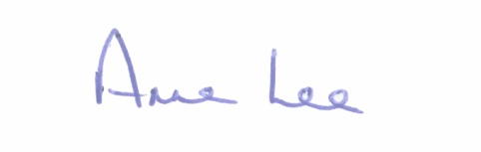
Signed: _______________
Anne Lee,
Meetings Administrator.

Confirmed and adopted at Ballymahon Municipal District Meeting held on the
27th September 2018.

Signed: _______________
Cathaoirleach.

